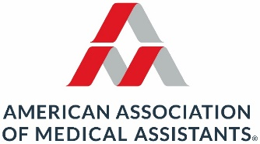
2027 AAMA Annual Conference Site Consideration Form

In affixing your signatures below, you are authorizing your state(s) to be considered as the site of the 2027 AAMA Annual Conference. You understand that, if selected, the conference site could be anywhere in your state(s) that meets conference specifications. Complete the form and return it to Sharon Flynn, Board Services Manager, via email (SFlynn@aama-ntl.org) by May 15, 2025. If you have any questions, please contact Sharon Flynn, Board Services Manager, or President Virginia Thomas via email (VThomas@aama-ntl.org).
If your state(s) is chosen, you are responsible to work with the Conference Continuing Education Task Force (CCETF) of the Continuing Education Board (CEB) and AAMA staff to acquire speakers for the continuing education sessions.
Please check the appropriate box below. All signatures are required whether you are agreeing or declining.
☐ Yes, we wish for our state(s) to be considered as a site for the AAMA Annual Conference in 2027.
☐ No, we do not want our state to be considered as a site for the AAMA Annual Conference in 2027.
State Society President (Print Name and Sign):
Date: Email address:
State Society Vice President (Print Name and Sign):
Date: Email address:
State Society Treasurer (Print Name and Sign):
Date: Email address:

Optional: Multiple state societies may team up to host the AAMA Annual Conference. Provide the required information below for additional state society members.
State Society President (Print Name and Sign):
Date: Email address:
State Society Vice President (Print Name and Sign):
Date: Email address:
State Society Treasurer (Print Name and Sign):
Date: Email address:

