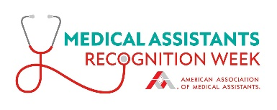Sample Press Release

*Use the sample press release below as a guide in developing your own announcement about local activities related to Medical Assistants Recognition Week. Send through an online press release distribution service. And share with local newspapers, magazines, and radio stations.*

|  |
| --- |
| **For release: Contact:**  [Insert desired date of release] [Insert contact name, phone, and email]  **Medical Assistants Recognition Week Celebration**  [CITY, STATE]—The [local chapter or state society] is gearing up to celebrate Medical Assistants Recognition Week, [insert dates and year], as designated by the American Association of Medical Assistants® (AAMA). Medical assistants across the country will be recognized during this special week and honored on Medical Assistants Recognition Day, [insert date].  In celebration of Medical Assistants Recognition Week, the [local chapter or state society] has planned the following special events and activities:  [List activities, locations, and dates here.]  “[Insert quote from event planner or state or chapter president],” says [name and title].  Medical assisting is an allied health profession whose practitioners function as members of the health care delivery team and perform administrative and clinical procedures. With their unique versatility, medical assistants are proving to be the allied health professional of choice for this decade and beyond. Medical assisting is one of the nation’s careers growing much faster than average for all occupations, according to the U.S. Bureau of Labor Statistics.  The AAMA is the only organization devoted exclusively to serving the professional interests and educational needs of all medical assistants. The association provides numerous services that help medical assistants put their careers on a successful and rewarding track and keep them there. |