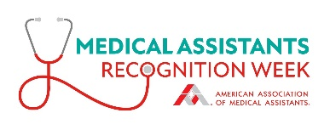Sample Proclamation

Use the sample proclamation below as a guide to encourage elected officials, including mayors, city managers, county executives, and state governors to designate every third full week in October as Medical Assistants Recognition Week.

|  |
| --- |
| [Insert date] **Contact:**  [Insert city, state] [Insert contact name, phone, and email]  Medical Assistants Recognition Week Proclamation  Whereas, medical assistants are multiskilled allied health professionals who perform a wide range of administrative and clinical roles with skill, dedication, and loyalty; and  Whereas, medical assistants are the central figures in promoting and maintaining cooperative and successful relationships between patients and physicians; and  Whereas, medical assistants are vital members of the health care delivery system; and  Whereas, medical assistants make a substantial contribution to the quality of health care in the United States;  Now, therefore, I [name and title] of the [state or municipality name or name of other governing body] do hereby proclaim the week of October [insert dates and year] as Medical Assistants Recognition Week.  [Your/official’s name], [your/official’s title] Witness: [title], [name] |